

**lrtjg ;lqmo dlxnf k|lti7fg**

jflif{s k|ult k|ltj]bg

**@)*)÷@)*!**

**e/tk'/ dxfgu/kflnsf**

**j8f g+=!! ,d'lQmgu/ dfu{**

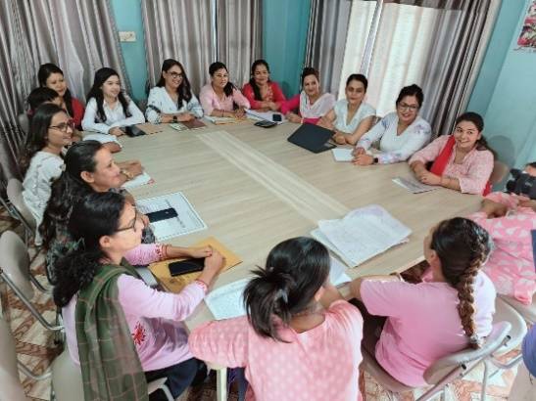**lrtjg ;lqmo dlxnf k|lti7fg**, Pr=cfO{=le ;+qmldt dlxnfx?¢f/f ;+qmldtx?sf] :jf:Yo, lzIff / plgx?dfly ul/g] nf~5gf / e]befj lj?4 jsfnt ug]{ p2]Zon] lj=;+= @)^! ;fndf btf{ u/L :yfkgf u/LPsf] Ps u}x| ;/sf/L ;fdflhs ;+:yf xf] . o; ;+:yfn] Pr= cfO{= le= df dfq geO{ dlxnf clwsf/sf If]qdf klg sfo{qmd ;+Rffng ub}{ cfO/x]sf]5 . lrtjg lhNnfnfO{ sfo{If]q agfO{ ljleGg ;f]em]bf/ ;+:yfx?sf] sfo{ cg'ej;Fu}, :yflgo ;/sf/sf] ;dGjodf Pr=cfO{=le /f]syfd / dlxnf tyf afnaflnsf nflu ljleGg sfo{qmd ;+Rffng ub}{ cfO/x]sf]5 . xfn ;]e b lrN8«]gsf] ;xof]udf k|jf;L / k|jf;Lsf] kl/jf/sf] sfo{qmd cGtu{t Pr=cfO{=le, l6=la, of}g/f]u / dn]l/of ;DalGw ;'rgf lzIff, Pr=cfO{=le tyf dn]l/of kl/If0f Pjd\ k|]if0f tyf ;dGjo, ug'{sf ;fy} s]o/ P08 ;kf]{6 sfo{qmd cGtu{t Pr=cfO{=le ;+qmldtsfnflu ;fd'bflos x]/rfx s]Gb| (CCC) ;]jf, 3/ tyf ;d'bfodf g} uP/ ;+qmldtx?nfO{ :jf:Yo, ;fdflhs tyf dgf];fdflhs ;]jfx? (CHBC) nufot OG8]S; SnfOG6 / hf]lvdo'Qm ;d'bfodf Pr=cfO{=le kl/If0f ;]jf k|bfg ub}{ cfO/x]sf] 5 . To:t} u/L, !* jif{ d'lgsf Pr=cfO{=le ;+qmldt afnaflnsfsf nflu dfl;s ?= !))) sf b/n] sfjf ;fdflhs ;'/Iff cg'bfg sfo{qmd klg ;+rfng ub}{ cfO/x]sf]5 . dlxnf clwsf/sf] ;jfndf PSzg P8\ tyf cfO{l/; P8sf] ;xof]udf ;d'GgtL kl/of]hgf cGtu{t dlxnf tyf lszf]/Lsf] Ifdtf clej[l¢ u/L ;zlQms/0f ug'{sf ;fy}hnjfo' kl/j{tgn] l;dfGts[t ;d'bfonfO{ kf/]sf] k|Effjsf] ;jfndf klg sfo{qmdx? ;~rfng ub} cfO/x]sf] 5 .

**sfo{If]q** M dlxnf clwsf/sf] ;jfndf df8L gu/kflnsfsf] j8f g+ !,#,%,^ / Pr=cfO{=le ;+qmldtx?sf] ;jfndf lrtjg lhNnfsf ;a} / ;fd'bflus x]/rfx s]Gb|af6 cGo lhNnfsf Pr =cfO{=le ;+qmdltx?nfO{ klg ;]jf lbFb} cfO/x]sf]5 .

Mission M

lrtjg ;lqmo dlxnf k|lti7fgn] nIodf k'Ug lgDg Woo]sf cfwf/df cfˆgf] e"ldsfnfO{ ;'b[9 kfg]{ sfd ub{5 M

* clt pRr hf]lvddf /x]sf dflg;x?af6 ;g{;Sg] Pr=cfO{=le÷P8\;sf] Iflt Go'lgs/0fsf nflu ;xsfo{ ug]{ .
* dlxnf clwsf/nfO{ k|aw{g ug{ dlxnfx?sf]] ;Lk / cg'ejsf] k|of]u u/L ;xof]u / ;dy{g ug]{ .
* ;dfhsf x/]s If]qaf6 e]befj / b'Jo{jxf/ x6fpg] .
* dlxnf lj?¢ ;a} k|sf/sf lx+;fsf] cGTo ug]{ .
* ;dfhdf ;dfgtf / Gofosf] k|aw{g ug]{ .
* Pr=cfO{=le ;+qmldt Pjd\ cfjZostf k/]sf] JolQmsf] lbuf] lhljsf]kfh{gsf nflu ;/sf/L lgsfo / /fHo;Fu jsfnt ug]{ .

nIox? M

* nlIft ;d'x / sfo{If]qdf ;d'bfodf cfwf/Lt cGt/lqmofTds sfo{ ug]{
* Pr=cfO{=le ;+qmldtx?sf] zf/Ll/s, dfgl;s, ;fdflhs / cfly{s cfjZostfdf ;xof]u ug]{
* Pr=cfO{=le ;+qmldtx?sf] x]/rfx / ;xof]udf ;dy{g a9fpg]
* k|efjsf/L / Go'g bf]xf]/f]kgsf nflu :yflgo lgsfo, gful/s ;dfh, ;/sf/L lgsfo, ldl8of, lghL / ;+ul7t If]qx?;Fu gflhssf] ;DaGw :yfkgf ug]{ / ;dGjo lj:tf/ ug]{
* Pr=cfO{=le ;+qmldt Pjd\ gful/s ;dfhsf] ;xeflutf dfkm{t Pr=cfO{=le ;DalGw hf]lvd / IfltnfO{ sd ug]{
* Pr=cfO{=le÷P8\;sf] /f]syfd, x]/rfx / pkrf/df kx'Fr a9fpg]

**Pr=cfO{=le sf] ;jfndf ;+Rffng ug{] sfo{qmdx?**

1. [Global Fund- Save The Children Nepal](https://nepal.savethechildren.net/global-fund)

* **sf] ;xof]udf ;+rflnt sfo{qmd M**
* **Care & Support Component:**

**!=CHBC M** Pr=cfO{=le ;+qmldtx?sf] 3/ tyf ;d'bfodf uO{ :jf:Yo, ;fdflhs, tyf dgf];fdflhs ca:yfsf] af/]df hfgsf/L lnO{ cfjZos ;]jf tyf ;xof]udf lbO{/x]s]f 5 . h;df ;+qmldtx?n] lgoldt P=cf/ le ;]jf lnO{/x]sf] 5 , 5}g klxrfg u/L k/fdif{sf] dfWod af6 lgoldt cf}ifwL ;]jf lng] jftfj/0f ;[hgf ul//x]sf] 5 . ;+qmldtx?nfO{ s'g} cGo /f]u pkrf/ / ;]jf ;'ljwfsf] nflu klg ;DalGwt lgsfodf /]km/ ug]{ ;]jf k|bfg ub}{ cfO/x]sf] 5 . cf=j= @)*)÷)*! df hDdf @^# hgfnfO{ CHBC ;]jf k|bfg ul/Psf]5 .

CHBC ;]jf cf=j= )*)÷)*!

**@=CCC M** Pr=cfO{=le ;+qmldtx?sf] :jf:ydo lhjgofkgsf nflu pkrf/df kFx'r a9fpg ;fy} P=cf/=le ;'? ubf{ b]lvg;Sg] ;fO8 Okm]S6nfO{ ;dodf g} ;dfwfg ug]{ p2]Zon] !% lbg tyf cfjZostf x]/L s]xL lbgsf lgM z'Ns a:g / vfgfsf] ;]jf k|bfg ub}{ cfO/x]sf] 5 . o;sf ;fy}} nfdf] b'/Laf6 ;]jf lng cfPsf ;+qmldtx?nfO{ klg cfly{s ef/ sd ug]{ x]t'n] cGo ;+qmd0fsf] pkrf/sf] nflu klg ;fd'bflos x]/rfx s]Gb|af6 ;]jf k|bfg ub}{ cfO/x]sf] 5 . cf=j= @)*)÷)*! df hDdf @)* hgfnfO{ ;fd'bflos x]/rfx s]Gb|af6 ;]jf k|bfg ul/Psf]5 .

CCC Service cf=j= )*)÷)*!

# **= CABA cg'bfg sfo{qmd M** Pr=cfO{=le ;qmldt afnjflnsfx?nfO{ dfl;s ?kdf lzIff, :jf:Yo / kf]if0fsf nflu ?= !))) sf] b/n] ;xof]u ub{} cfO{/x]sf] 5 . xfn cg'bfg ;]jf lnO/x]sf sfjfx? hDdf #( hgf /x]sf 5g\ .

CABA Service cf=j= )*)÷)*!

|  |  |  |  |
| --- | --- | --- | --- |
| *Pr=cfO=eL / P8\; sfo{qmd – s]o/ P08 ;kf]6{* | | | |
|  | Programs | Target | Achievement |
| ! | Community Home Based Care | @#^ | @^# |
| @ | Community Care Center | !#! | !$* |
| # | Nutrition Support for children | @ | ! |
| ^ | Support For cd4 support ,HB,TCDC,LFT,HCV Test | #^ | !) |
| & | Complicated Medical Treatment | @$ | ( |
| * | Viral load- Event | !@ | % |
| ( | Viral Load Sample collection | #^) | @^) |
| !) | Community Led Testing | $!^ | $)) |
| !! | IG Support | @ | @ |
| !@ | PLHIV initiative ART from CCC |  | !! |
| *sfo{qmd ;dGjo M* | | | |
| !# | CABA cash transfer Program | $@ | #( |
| !$ | CABA Coordination Meeting | @ | @ |
| !% | ART Coordination Meeting | ! | ! |

**Migrant and Their Spouse Component:**

!= **k|jfl; / k|jfl;s kl/jf/nfO{ Pr=cfO{=le tyf P8\; sfo{qmd M**

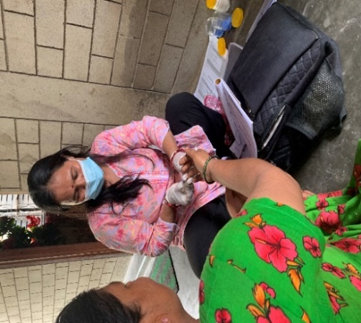;]e b lrN8«]gsf] ;xof]udf lrtjgsf] OR5fsfdgf ufpFkflnsf, sflnsf, dfl8, v}/xgL, /fKtL Pj+d\ /Tggu/ gu/kflnsf / e/tk'/ dxfgu/kflnsfdf a}b]lzs /f]huf/sf nflu ljz]ifu/L ef/tdf cfjt hfjt ug]{ k|jf;L / k|jf;Lsf kl/jf/nfO{ Pr=cfO{=le, l6=la, of}g /f]u, dn]l/of tyf cfjZostf x]/L cGo /f]u tyf dxfdf/Lsf sf] af/]df ;'rgf lzIff k|bfg ug]{, s08d ljt/0f / tflnd k|fKt Nofj cl;:6]G6 tyf cfp6l/r js{/x?¢f/f ;fd'bflos :t/sf] Pr=cfO{=le / dn]l/of kl/If0f, x]Ny SofDk nufot l6=aL l:s|lgª / k|]if0f tyf lnª\s]h ug]{ sfo{qmx? ;~rfng ul/Fb} cfO/x]sf] 5 .

BCC kl5 CLT Test ub}{

Programmatic Performance of Migrant Component -080**÷**81

Programmatic Performance of Migrant Component -080÷81

**sfo{qmdsf] dVo r'gf}tLx?**

* l;ldt CHBC 6f]lnsf sf/0f / ;]jfu|xLx?sf] dGh'/L gx'Fbf lrtjgsf ;a} ;]jfu|xLx?nfO{ ;]jf lbg g;lsPsf] .
* Gfful/stf aGg g;s]sf ;]jfu|flxx?sf] aLdf ug{ gkfpFbf / gofF ;+qmldtx?nfO{ :jf:Yo pkrf/ ;]jfdf sl7gfO{
* ;+qmldt JolQmx?sf] cfly{s cefjsf sf/0f cfkm'n] vfg'kg]{ cf}iflw lng cfpg tyf cf}iflwpkrf/df l9nfO ul/Psf] kfOG5 .
* Determine Reactive kl5 Conformation Test sf nflu tNsfn} Pcf/eL ;]jfdf n}hfgsf nflu w]/} ;d:ofx? ;fdgf ug'{k/]sf] .
* PrcfO{eL hfFrsf nflu cfjZos ls6 ;dodf cfk'lt{ x'g g;Sbf pknlAwdf c;/ k/]sf]
* s'g} j8fx?df ;d'bfosf JolQmx?n] Pr=cfO{=le= kl/If0f tyf ;'rgf lzIff k|jfxnfO{ gs/fTds ?kdf x]/L g/fd|f] Jojxf/ ug'{sf ;fy} j8f / :jo+;]ljsfx?sf] klg /fd|f] ;xof]u gkfPsf] .

2.[ActionAid Nepal](https://nepal.actionaid.org/) **sf] ;xof]udf ;+rflnt sfo{qmd**

**Dflxnf clwsf/sf] ;jfndf ;+rfng ul/Psf] sfo{qmd M**

**!= dlxnf tyf lszf]/L ;d'x u7g tyf kl/rfng M**  ;d'Gglt kl/of]hgf ;+rfng ug'{cl3 ul/Psf] ;j]{If0f / :yflgo tx;+usf] ;dGjodf clt hf]lvd If]qsf] klxrfg ul/Psf] lyof] . $ g+=j8f df !) j6f dlxnf tyf lszf]/L ;d'x u7g ul/Psf] lyof] . h;df # j6f dlxnf ;d'x k'g/ u7g ul/Psf] lyof] eg] % j6f dlxnf ;d'x / @ lszf]/L ;d'x gofF ;d'x lgdf{0f ul/Psf] lyof] . Pp6f ;d'xdf @) b]lv @% hgfsf] ;b:o /x]sf] kfO{G5 . ;d'bfodf clt ljkGg au{, e'ldlxg, ljkbsf] hf]lvd :yfgdf, lj:yflkt j:tL / lx+;fsf] lx+;fjn] hf]lvd :yfgsf dlxnfx?nfO{ ;d'x lgdf{0f ul/ dlxnfx?sf ;jfnx?df b]vf k/]sf ;d:ofx?nfO{ dlxnf ;d'x;+u lg/Gt/ e]6 ul/ :yflgo ;]jf k|bfossf] hfgsf/L ,of]hgf th'{dfsf] ;do / k|lqmof ,dlxnf tyf lszf]/Lx? dfly x'g] lx+;f, dlxnfx?sf] sfdsf] af8kmfF8 sf] ;jfndf lg/Gt/ 5nkmn dlxnf tyf lszf]/Lx?sf] Ifdtf ljsf; ug]{ sfd ul/Psf] lyof] .

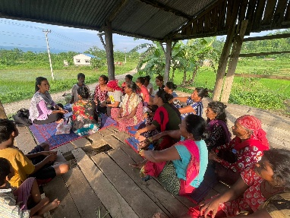 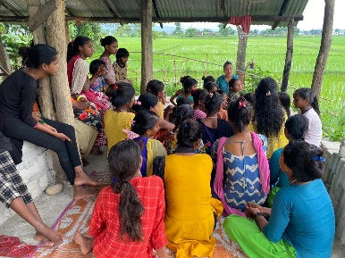



**\**

**@= lszf]/Lx?nfO{ jfnljjfxf / o;n] kfg{] c;/sf] ;jfndf @ lbgsf] tflndM**

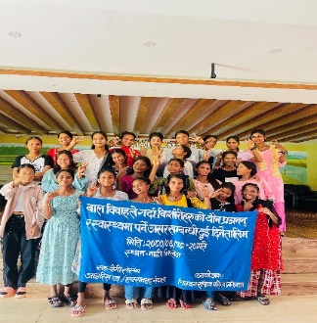 dfl8gu/kflnsf j8f g+ # df u7g ul/Psf] lbk Hof]tL lszf]/L ;d'xsf k|ltlgwLx?nfO{ afnljjfx / o;n] lszf]/Lx?sf] of}g tyf k|hgg / :jfYo clwsf/sf] ;jfndf kg{] c;/sf] ;jfndf ldlt @)*)÷)^÷!( / @) ut] tb cg';f/ ^ / & cS6'a/ @)@# sf lbg dfl8 len]hdf @ lbgsf] tflndsf] cfof]hgf ul/Psf] lyof] . tflnddf afnljjfxfsf] kl/efiff h;df g]kfnsf] sfg'g jfnljjfxfsf] xb Dofbsf] ;jfndf yfxf kfPsf] ldltn] # dlxgf leq ph'/L ug'{k5{ . lszf]/Lx?nfO{ afnljjfxfsf] sfg'gL k|s[ofsf] af/]df ;r]t u/fP kl5 o;n] kfg{] c;/x?sf] af/]df hfgsf/L u/fO{Psf] lyof] . o; tflndf hDdf @$ hgf lszf]/Lx?sf] ;xefuLtf lyof] .

**#= dlxnf ;d'xsf k|ltlgwLx?nfO{ dlxnf ;d'x u7g, dxTj, ;fdflhs :kfGt/0f / n}luslx+;f lj?4sf] ;jfndf # lbgsf] tflnd M**

o; # lbgsf] tflnd ldlt @)*)÷)*÷@$ ut] b]lv @& ut] tb cg';f/ !) l8;]Da/ !@ l8;]Da/ @)@# ;Dd e/tk'/sf] lrtjg uf8{]g l/;f]6{df ;DkGg ul/of]  . of] tflnd laz]if ul/ dlxnf ;d'xsf] cfjZostf, Ps?ktfn] k5f8L kfl/Psf dlxnfx?nfO{ plgx?sf] Ifdtf ljsf; ul/ :yflgof txdf plgx?sf] kFx'r / lgoGq0f a9fpg' xf] . dlxnf clwsf/ tyf plgx?sf] clwsf/ k|fKtsf] nflu tyf dlxnfx?sf] g]Q[Tj / dxTjsf] af/]df hfgsf/L u/fO{Psf] lyof] . ;d'bfodf dlxnf tyf lszf]/L dflyx'g] of}ghGo lx+;f ePDff ph'/L lbg] lgsfo j8f b]lv lhNnf / /fli6«o:t/ ;Ddsf] lgsfox?sf] hfgsf/L u/fO{Psf] lyof] . tflnddf dfl8gu/ kflnsfdf u7g ul/Psf * j6f dlxnf ;d'xsf @$ hgf dlxnfx? k|ltlgwLx?sf] pkl:yLt /x]sf] lyof]

**$=cGt/fli6«o dof{lbt dlxgfjf/L ;DaGwL Ps Ps lbgsf] cled'lv/s0f sfo{qmd**

**M** 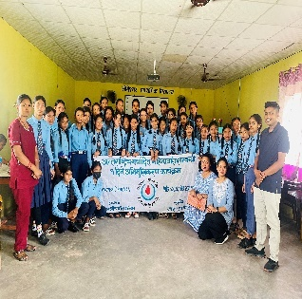 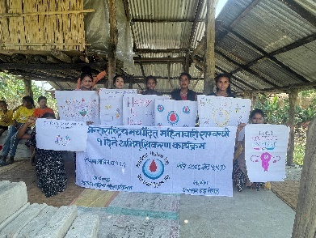

dfl8 gu/kflnsfsf] @ j6f :S'nx? j8f g+ ! sf] ;f]d]Zj/ df=lj, j8f g+ ^ sf] hg sNof0f df=lj / dnfO{6f]nsf k9fO{ 5f]8]/ a;]sf lszf]/Lx?nfO{ dof{lbt dlxgfaf/Lsf] ;jfndf Ps Ps lbgsf] cled'lvs/0f sfo{qmdsf] cfof]hgf ul/Psf] 5 . ;f]d]Zj/ df=lj df ;d'GgtL kl/of]hgfsf] ;xof]udf :s'ndf ph'/L k]6Lsf /flv Joj:yfkgsf nflu lzIfs,5fqf 5fq ;lxt !% hgf ;ldlt u7g ul/ n}lus lx+;f cGTosf nflu kxn ul/Psf] lyof] . @ j6f :s'ndf (# hgf lszf]/L !) hgf dlxnf / % hgf k'?ifsf] ;xefuLtf /x]sf] lyof] .

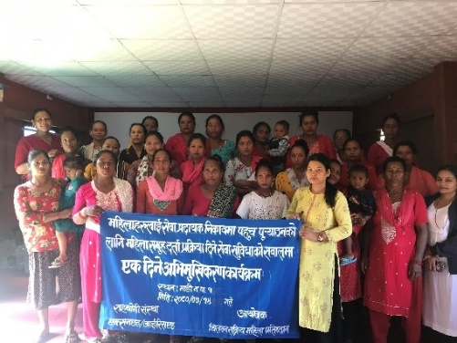**%= dlxnf ;d'xsf k|ltlgwLx?nfO{ :yflgtxdf dlxnf ;d'x u7g / of]hgf th'{Dffsf] ;jfndf Ps lbgsf] tflnd M**

ldlt @)*)÷)&÷ !$ ut]sf lbg ! g+ j8fsf] Go' dlxnf ;d'x / zflGt dlxnf ;d'xsf @* hgf k|ltlgwLx?nfO{ :yflgo txdf ;d'x btf{ / :yflgo ;]jf ;'ljwfdf dlxnfx?sf] kFx'r a9fpgsf nflu Ps lbgsf] cled'lvs/0f sfo{qmd ;DkGg ul/Psf] lyof] . :yflgo txsf] of]hgf th'{dfsf] & j6f r/0fsf] af/]df hfgsf/L u/fpg'sf ;fy} j8f :t/sf] j8f e]nf slxn] x'G5, j8f e]nfsf] dxTjsf] / o;sf] k|s[ofsf] af/]df hfgsf/L u/fO{Psf] lyof] .

**&=dlxnfx?sf] cfly{s ca:yf ;'wf/sf] nflu cfkmgf] Joj;fo lj:tf/ tyf ;'wf/ tflnd**M

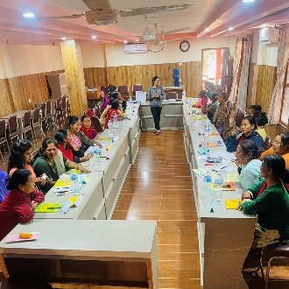sfo{If]qsf Jojf;o ug{ O{R5f ePsf dlxnf tyf cfocfh{gsf] sfd ul//x]sf @% hgf dlxnfx?nfO{ @$ gf]e]Da/ b]lv @* gf]e]Da/ @)@# ;Dd % lbgsf] tflnd ;f}/fxfsf] xf]6n g]r/ x]l/6]hdf ;DkGg ul/Psf] lyof] . dlxnfx?nfO{ Joj;foLs ?kdf cuf8L a9fpgsf nflu Joj;foLs of]hgf ,ahf/ Joj:yfkg, :yflgo sRrf kbfy{, ljlQo ;fIf/tf h:tf ljifo a:t' ;dfa]z ul/ % lbgsf] tflnd ;DkGg ul/Psf] 5 . tflnddf @% hgf dlxnfx?sf] ;xefuLtf /x]sf] lyof] .

**\*= dlxnfx?sf] cfly{s ca:yf ;'wf/sf] nflu :yflgo lgltsf] ;jfndf Ps lbgsf] sfo{Zffnf uf]i6L .**

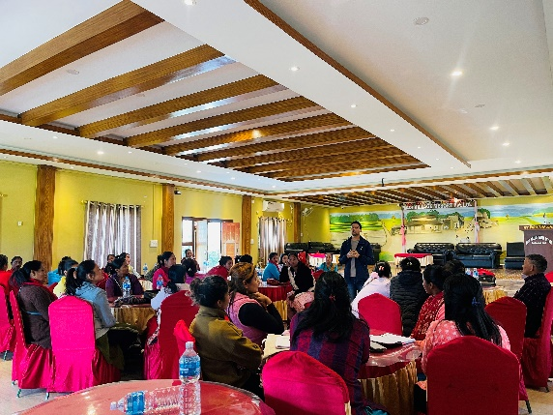

;d'bfodf u7g ul/Psf] dlxnf ;d'xsf k|ltlgwLx?nfO{ dlxnfx?sf] cfly{s ca:yf ;'wf/sf] nflu :yflgotxn] agfPsf] lglt / sfo{Gjgosf] ca:yfsf] ;jfndf ldlt @) l8;]Da/ @)@# df Ps lbgsf] sfo{zfnf uf]i6L dfl8 s6]hsf] ;efxndf ;DkGg ul/of] . pkl:yLt ;xefuLx? w]/}h;f] s[lif k]zfdf cfwfl/t eO{ cfkmgf] lhljsf] kfh{g ub{} cfO{Psf lyP . uf]i6Ldf gu/kflnsfn] Jojf;foLs s[lif / lgjfxf{d'lv s[lif ul/ @ efudf ljefhg ul/Psf] 5 / ;f]xL cg';f/sf] ;]jf k|jfx u/]sf] hfgsf/L u/fO{Psf] lyof] . ;d'bfodf clt ljkGg au{ h;n] P]nfgL hUuf,csf{sf] hUuf ef8f tyf sdfpg]x?sf] nflu klg j8f af6 l;kmf/L; lnO{ kmd{ btf{ ug{ ;Sg] lgltsf] af/]df klg hfgsf/L u/fO{Psf] lyof] . To;}u/L lszfgx?nfO{ lbO{g] cg'bfg, ljp ljhg, df6f] kl/If0f, h:tf ;'ljwfx? :yflgotxn] lbg] hfgsf/L u/fO{Psf] lyof] .;fy} dfl8gu/ kflnsfdf dT:okfngsf] lx;fjn] klg ;Defjgf /x]sf]n] ubf{ o;sf] nflu klg :yflgo b]lv k|b]z ;/sf/n] ;d]t cg'bfg lbg] lgodsf] af/]df hfgsf/L u/fO{of] . sfo{qmddf %# hgf dlxnfx?sf] ;xefuLtf /x]sf] lyof] .

**(=hnjfo' kl/j{tgsf] ;jfndf o'jf / ;]jfk|bfos ;+:yfsf k|ltlgwLx?;+u ;+rfng ul/Psf] sfo{qmdx? M**

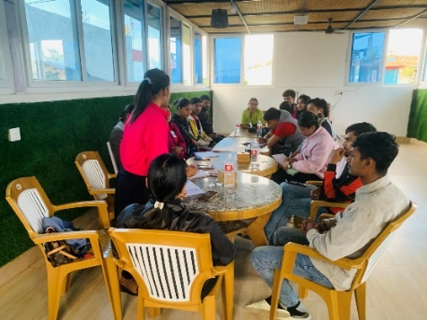**!= o'jf ;d'x u7g tyf kl/rfng**

hnjfo' Gofo, n}lus lx+;f cGTosf nflu kl/of]hgfsf] sfo{If]q dfl8gu/kflnsf !,#,% / ^ cGo j8fsfo'jfx? -dlxnf tyf k'?if_ ul/ hDdf @) hgfsf] ;d'x lgdf{0f ul/Psf] lyof] . o'jfx?nfO{ ;d'x u7gsf] p4]Zo af/]df k|i6 kfb{} ;d'bfodf dlxnf tyf lszf]/Lx?nfO{ s:tf vfnsf] lx+;f tyf 36gfx? x'g] ul/Psf] 5 ,:yflgo ;]jf k|bfos n}lus d}lq 5 ls 5}g,;d'bfosf clt ljkGg ;d'bfosf JolQx?sf] :yflgo ;]jf ;'ljwfdf kx'Fr k'u]sf] 5 ls 5}g eGg] ljifodf hfgsf/L lngsf] nflu j[If ljZn]if0fsf] k|of]u ul/ ;d:of / ;dfwfgsf] klxrfg ul/Psf] lyof] .

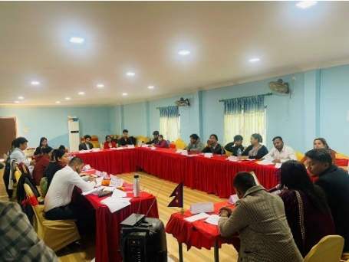**@ =gd'gf gu/ zefsf] ;jfndf o'jfx?nfO{ # lbgsf] tflnd M**

df8Ldf u7g ul/Psf @) hgf o'jf ;d'xsf k|ltlgwLx? / # hgf ;fdflhs kl/rfns ;lxt @# hgf o'jfx?nfO{ df8L gu/kflnsfdf klxnf] # lbgsf] gd'gf o'jf gu/ ;ef !% b]lv !& l8;]Da/df lrtjgsf] zf}/fxfdf ;DkGg ul/Psf] lyof] . gd'gf gu/ ;efdf o'jf clwsf/ tyf o'jf kl/rfng s;/L ug{] / :yflgotxdf l;dfGts[t ;d'bfosf] kFx'r a9fpgsf nflu tflnd ;+rfng ul/Psf] lyof] .

**#=hnjfo' kl/j{tgn] l;dfGts[t ;d'bfonfO{ kf/]sf] k|Effjsf] ;jfndf k|b]z:t/Lo sfo{zfnf uf]i6LM**

lrtjg ;lqmo dlxnf k|lti7fg, :jfd g]kfn, dsjfgk'/ dlxnf ;d"x / o'jf cleofgsf] cfof]hgf / PS;g P8 g]kfnsf] ;xof]udf afudtL k|b]z :t/Lo ;Dd]ng ;DkGg eof] . dsjfgk'/sf] ;fdgf xf]6ndf ;DkGg ;Dd]ngdf afudtL k|b]zsf !# lhNnfdf a;]/ ljleGg ;~rf/ dfWoddf sfo{/t kqsf/, lrtjg / dsjfgk'/sf hnjfo' ;+s6 k|efljt ;LdfGts[t ;d"bfosf ;b:o, k|b]z :t/sf gLlt lgdf{0f txsf JolQm, o'jf tyf ljleGg ;/f]sf/jfnf ;+:yfsf JolQmx?sf] ;xeflutf /x]sf] lyof] .

**jflif{s tYofs+**

|  |  |  |
| --- | --- | --- |
| ;d[l4 kl/of]hgf | | |
| ! | lx+;fsf 36gf btf{ eO{ Gofo kfPsf | @! hgf |
| @ | dlxnf clwsf/ sdL{ lgdf0f{ | @% hgf |
| # | k'?if dlxnf clwsf/ sdL{ lgdf0f | !% hgf |
| $ | lx+;f k|efljt dlxnfx?nfO{ sfg'gL ;xof]u | !! hgf |
| * | lhjLsf] kfh{g ;xof]u | @% hgf |
| ( | n}lus lx+;f cGTosf nflu ;r]tgf | !@% hgf |
| !) | dlxnf clwsf/ / sfg'gL k|s[ofsf] ;jfndf ;r]t | @!% hgf |
| !! | hnjfo' kl/j{tg / o;n] kf/]sf] k|Effjsf] ;jfndf ;r]tgf | #!% hgf |

**sfo{qmd ;+rfng af6 cfPsf pknAwLx? M**

* sfo{If]qsf @! hgf lx+;f k|efljt dlxnfx?nfO{ sfg'gL k|s[ofdf hfg ;xlhs/0f ul/Psf] 5 h;df !$ hgfn] Gofo kfPsf 5g .
* :yflgo :s'n ;+u ul/Psf] ;dGjon] :s'n hfg5f]8]sf] * hgf lszf]/L dWo] @ hgf k'g :s'n egf{ ePsf 5g eg] % hgf lszf]/Lx/n] l;nfO{ tflnd lng yfn]sf 5g .
* :yflgo :t/sf] ;dGjo clt ljkGg au{sf kl/jf/x?sf] lhjg :t/sf] nflu 3/ agfpg ;xof]u # kl/jf/sf]
* ! hgf !! sIff kl9 :S'n 5f]8L a;]sf] lszf]/LnfO{ sn]h ;+u ;dGjo ul/ k'g k9fO{ lg/Gt/tfdf ;xhLs/0f ul/of] ,!) hgf clt ljkGg au{sf dlxnfx?nfO{ s[lif ;d'xdf btf{ u/fO{ lgz'Ns ljdf u/fPsf] 5 . !)% hgf dlxnfx?nfO{ lgz'Ns :jf:Yo ljdf u/L lgz'Ns :jf:Yo pkrf/ ug{ ;kmn ePsf 5g .
* lg/Gt/ ul/Psf] ;fdflhs kl/rfng af6 ;d'bfosf dlxnfx?sf] Ifdtf ljsf; eO{ @^ hgf dlxnfx? :yflgo ;|f]t kl/rfngsf] ;dltdf ;b:o ePsf 5g h;df 6f]n ;'wf/ ;ldltdf !! ,ljwfno Joj:yfkg ;ldltdf & hgf,akm/h+udf * hgf ;b:o eO{ dlxnf clwsf/sf] ;jfndf jsfnt ug{] ;Sg] ePsf 5g .h;n] ubf{ dlxnfx?sf] nflu lgz'Ns :jfYo ljdf ,:s'nx?Dff kflg ;lxtsf] zf}rfno / lszf]/Lx? dfly x'g] lx+;f lj?4 cfjh p7fpg yfn]sf 5g . h;df # hgf lszf]/L lj?4 of}g lx+;f btf{ ePsf]
* lg/Gt/ ;fdflhs kl/rfgn] ubf{ !@ hgf dlxnfx?sf] lg0f{o ug{ ;Sg] Ifdtfsf] ljsf; ePsf] h;n] ;d'bfodf n}lus lx+;f lj?4 cfjfh p7fpg yfNg ;Sg] ePsf 5g .
* ;d'bfodf & hgf dlxnfx?n] Joj;fo btf{ ul/ ;+rfng ug{ yfn]sf 5g .

**sfo{qmd ;+rfng af6 cfPsf r'gf}tLx? M**

* ;d'bfodf sfd ubf{ ljkt Joj:yfkgsf] ;jfndf sfd ul//xFbf dfl8 gu/kflnsfdf h+unL hgfj/ cft+s af6 dfgljo tyf jflnsf] Ifltx'Fbf ;d'bfon] ljkt xf] elg Ifltk'lt{sf] nflu bflj ubf{ :yflgotxn] ljkt ;dfa]z ug{ g;Sbf lkl8tn] Gofo kfpg g;s]sf] .
* lx+;f k|efljtdlxnfx?sf] 36gf af/Daf/ d]nldnfk x'bf lx+;f k|efljt c;xh x'g'sf] ;fy} cGo k|efljt dlxnfx? klg aflx/ cfpg gvf]Hg' .

3.[NFWLHA (National Federation Women Living With HIV/AIDs)](https://www.nfwlha.org.np/):

Pr= cfO{=le ;+qmldt dlxnfx?sf] /fli6«o dxf;+3 cGtu{t Catalytic Project / Epic project sf] ;xof]udf Pr=cfO{=le ;+qmldtsf ;jfn tyf d'¢fx?nfO{ lnP/ ;+qmldtx?;Fusf] a}7s tyf ;dGjo sfo{qmdx? ;~rfng ul/Psf lyof] . To:t} o'jf ;+qmldtx?sf ljifonfO{ lnP/ o'jf nlIft a}7s Pjd\ hf]lvdo'Qm ;d'bfosf JolQmx?dfly x'g]u/]sf nf~5gf, e]befj tyf lx+;fsf 36gfnfO{ sd ug]{ p2]Zon] a}7saf6 cfPsf d'2fx? :yflgo lgsfo Pjd\ :jf:Yo ;]jf k|bfos JolQmx?;Fu ;dGjo ul/ sfd ul/Psf] lyof] .

|  |  |  |  |
| --- | --- | --- | --- |
| *EPIC Project* | | | |
|  | Programs | Events | Participants |
| ! | Meeting with Youth PLHIV | # | $) |
| @ | Quarterly Meeting | $ | $) |
| # | Support Group Meeting | $ | ^) |
| $ | S & D Reduction Training | # | #) |
| *Catalytic Project:* | | | |
| ! | Regular Support Group Meeting | & | !)% hgf |

**Annexes 1.**

**Organizational Structure of Chitwan Sakriya Women`s Foundation (CSWF)**

Support Staff (1)

Social Mobilizers (3)

Admin/Finance Officer

Program Manager (HIV and AIDS Program)

Program Coordinator (Sakcham Project)

President

Advisory Committee

PLHA General Assembly

CSWF Board Members

Admin & Finance Officer - 1

M and E Officer -1

CCC In-charge (1)

Out-reach worker -5

Paramedic cum Counselor (1)

Support Staff (1)

* Cook (1)
* Care taker(1)
* Casual Labor

CHBC team

Case Tracker (2)

* CHBC Mobilizers (3)

Lab Assistant-2

Hospital Liaison Officer (1)

**Annexes 2.**

**Annexes 2.**

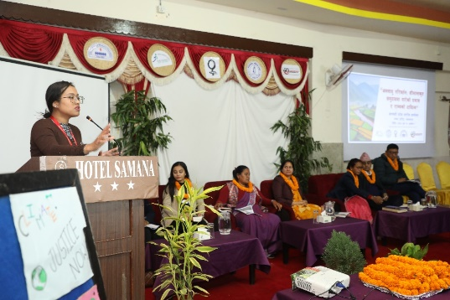 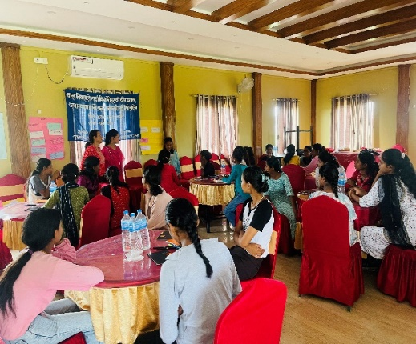 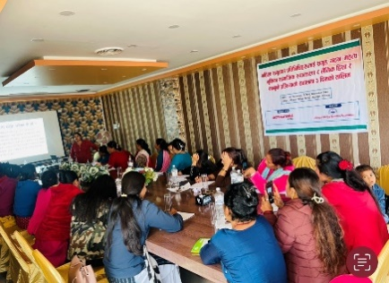

**k|b]z:t/Lo sfo{zfnf uf]i6L lszf]/Lx?nfO{ jfnljjfx lj?¢ tflnd dlxnf ;d'xsf k|ltlgwLx?nfO{ tflnd**

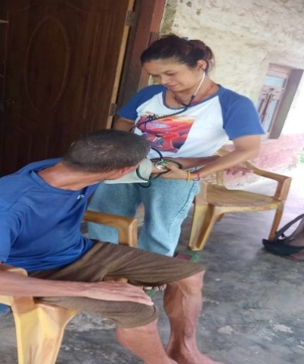 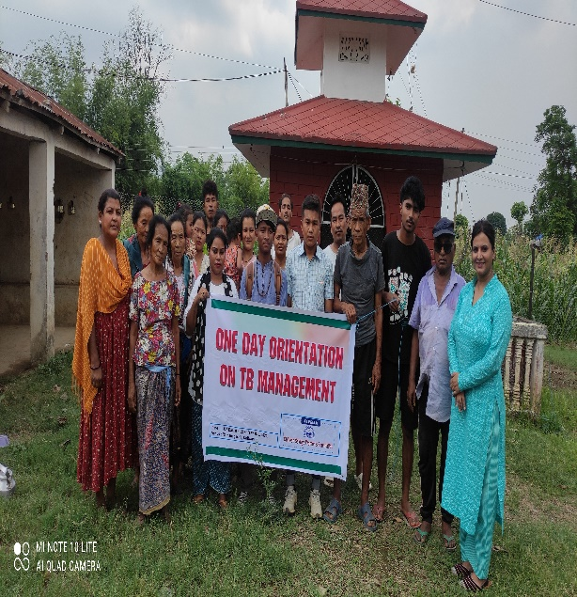 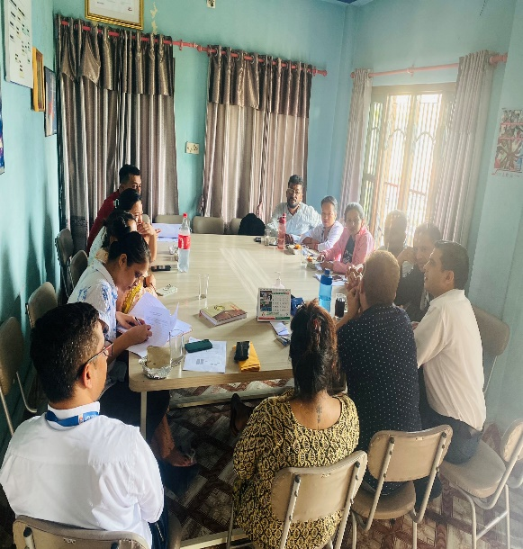

**CHBC ;]jf;Fu} :jf:Yo hfFr TB Management ;DalGw cled'lvs/0f ;/f]sf/jfnfx?;Fusf] a}7s**